
K S INSTITUTE OF TECHNOLOGY

# 14, Raghuvanahalli, Kanakapura Road, Bengaluru - 560109

Affiliated to VTU, Belagavi & Approved by AICTE, New Delhi

DEPARTMENT OF COMPUTER SCIENCE AND ENGINEERING

Activity Report on BCS508 - Environmental Studies and E- waste management for CSE Stream in Partial fulfillment for the award of Degree for the academic Year 2025-2026

A Report Entitled
Topic name – Environmental Pollution

Submitted By
Student Name | USN
MD. SUFIYAAN MECCAI | 1KS23CS084
PRANAV C M | 1KS23CS110
PRANAV SHASTRI | 1KS23CS111
PUNITH P | 1KS23CS116

Supervised by
Prof. RADHIKA N P
Assistant Professor
Department of Chemistry
K S Institute of Technology

DECLARATION

We, Md. SUFIYAAN MEECAI(1KS23CS084), PRANAV C M(1KS23CS110), PRANAV SHASTRI (1KS23CS111), PUNTIH P(1KS23CS116) hereby declare that the activity report entitled as “ENVIRONMENTAL POLLUTION ” was written by us in partial fulfillment for the degree under the guidance of Prof. RADHIKA N P, Assistant Professor, Department of Chemistry during the year 2025-2026.
To the best of our knowledge, the information provided in the report is true and correct.

USN | Student Name | Signature of the Student
1KS23CS084 | MD. SUFIYAAN MECCAI
1KS23CS110 | PRANAV C M
1KS23CS111 | PRANAV SHASTRI
1KS23CS116 | PUNITH P

Signature of the Supervisor

ABSTRACT

Hydrogen is emerging as a promising alternative energy source capable of transforming the global energy landscape. As the lightest and most abundant element in the universe, hydrogen serves as an energy carrier rather than a primary source. It can be produced from a variety of renewable and non-renewable resources, including water, natural gas, and biomass. When used in fuel cells or burned, hydrogen emits only water vapor, making it one of the cleanest fuels available. This report explores hydrogen’s properties, types, methods of production, storage, and transportation techniques, along with its advantages and challenges. It also discusses its applications in industries and transportation, case studies from countries like Japan and India, and future prospects for a hydrogen-based economy. With continued research, global investments, and policy support, hydrogen energy has the potential to replace fossil fuels and play a critical role in achieving sustainable development and net-zero carbon emission targets.

TABLE OF CONTENTS

SL.NO | CONTENTS | PAGE NO.
1 | Introduction | 5 - 6
2 | Methodology | 7
3 | Action and Future Plan | 8 -11
4 | Conclusion | 12 - 13
5 | References | 14

INTRODUCTION

- BACKGROUND:
The demand for clean, reliable, and sustainable energy has become one of the most critical global challenges of the 21st century. Traditional fossil fuels such as coal, oil, and natural gas have powered industrial growth for decades, but they have also led to severe environmental consequences most notably global warming, air pollution, and resource depletion. In this context, hydrogen has emerged as a promising alternative energy source due to its abundance, clean combustion properties, and versatility.
Hydrogen is the lightest and most abundant element in the universe, accounting for nearly 75% of all matter. However, it rarely exists in its pure form and is usually found combined with other elements such as oxygen (in water) or carbon (in hydrocarbons). Its true potential lies in its role as an energy carrier, meaning it can store and deliver energy produced from other sources, especially renewable ones like solar and wind. When used in a fuel cell, hydrogen reacts with oxygen to produce electricity, heat, and water the only by-product, making it a zero-emission fuel.
Historically, hydrogen has been used in industries such as refining, fertilizer production, and chemical manufacturing. However, with growing awareness of environmental issues and the urgent need for carbon neutrality, it is now being explored as a mainstream energy option for transportation, power generation, and industrial applications.
Countries like Japan, Germany, the USA, and India are investing heavily in hydrogen technology, indicating its global importance in the transition to a sustainable energy future.

- OBJECTIVES:

- To study the importance of hydrogen as an alternative and clean energy carrier.
- To understand various methods of hydrogen production, such as electrolysis, reforming, and gasification.
- To explore different types of hydrogen (grey, blue, green, etc.) and their environmental impact.
- To analyze challenges related to hydrogen storage, transport, and safety.
- To examine global case studies and government initiatives promoting hydrogen energy.
- To evaluate hydrogen’s future prospects in achieving a carbon-free economy.

- SCOPE AND IMPORTANCE:
The scope of this study extends across multiple sectors, including energy production, transportation, industrial applications, and environmental conservation. Hydrogen offers several unique advantages that make it a key element in the future energy mix:

- Environmental Benefits: Hydrogen produces only water vapor upon combustion, eliminating harmful pollutants and greenhouse gases.

- Energy Security: Hydrogen can be locally produced from renewable sources, reducing dependence on imported fossil fuels.

- Flexibility: It can be used in various forms — as a gas, liquid, or in chemical compounds like ammonia — making it adaptable for multiple uses.

- Industrial Relevance: Hydrogen is essential in steel, cement, and fertilizer industries to reduce emissions and maintain productivity.

- Sustainability: Green hydrogen, produced from electrolysis using renewable energy, offers a fully sustainable fuel cycle.
By adopting hydrogen energy, nations can simultaneously address environmental, economic, and energy security concerns paving the way toward achieving Sustainable Development Goals (SDGs) and net-zero emission targets.
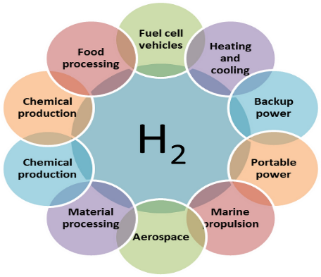
METHODOLOGY

This report is based on qualitative and analytical research methods using secondary data. The
approach followed includes:
- Data Collection: Information was gathered from trusted academic journals, government reports, and international energy agency publications such as IEA, DOE, and MNRE.
- Classification of Content: The collected data was categorized under headings like types, production, storage, advantages, challenges, and future prospects.
- Case Analysis: Real-world examples from countries like Japan, India, and Germany were studied to understand hydrogen’s practical implementation.
- Comparative Analysis: Hydrogen energy was compared with fossil fuels and other renewables to assess its environmental and economic performance.
- Collaborative Discussion: Team members collaborated to analyze findings, cross-verify data, and present the information cohesively.
This systematic approach ensured that the seminar content remains accurate, comprehensive, and aligned with the objectives of the Environmental Studies curriculum.
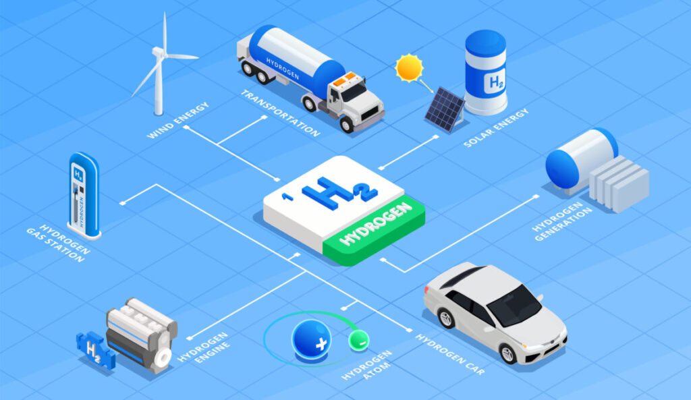
ACTION PLAN / FUTURE DEVELOPMENT PLANS
Hydrogen energy development requires a multi-phase approach involving technology, infrastructure, and policy frameworks. The following action plan outlines the key areas for future focus:
- Technological Innovation
- Increase efficiency of electrolyzers and fuel cells to lower production costs.
- Develop solid-state and composite storage materials for safer hydrogen storage.
- Invest in photocatalytic and biological methods for green hydrogen generation.

- Infrastructure Development
- Establish hydrogen refueling stations and dedicated pipelines for distribution.
- Integrate hydrogen with existing natural gas infrastructure for gradual transition.
- Build hydrogen hubs connecting industries, transport, and residential users.

- Policy and Investment Support
- Encourage public–private partnerships in hydrogen research and deployment.
- Provide subsidies, tax incentives, and funding for pilot projects.
- Implement strict safety standards for handling, storage, and transport.

- Education and Awareness
- Promote hydrogen education in engineering and science curricula.
- Conduct awareness programs highlighting hydrogen’s benefits and safety aspects.

- Global Cooperation
- Collaborate internationally to share technology, funding, and best practices.
- Participate in global hydrogen missions such as the International Partnership for Hydrogen and Fuel Cells in the Economy (IPHE).
- With these initiatives, hydrogen energy can transition from a developing technology to a mainstream energy system, enabling a clean, secure, and resilient global energy economy.
With these initiatives, hydrogen energy can transition from a developing technology to a mainstream energy system, enabling a clean, secure, and resilient global energy economy.

Hydrogen Extraction Techniques
Hydrogen does not exist freely in nature in large quantities; it is always combined with other elements such as oxygen (in water) or carbon (in hydrocarbons). Hence, it must be extracted or produced through specific processes that separate hydrogen from these compounds.
The main techniques used for hydrogen extraction are outlined below.

- Electrolysis of Water
Principle: In this method, an electric current is passed through water (H₂O) to split it into hydrogen (H₂) and oxygen (O₂).
Description:
The process occurs in an electrolyzer that uses either alkaline, PEM (Proton Exchange Membrane), or solid oxide technology. When powered by renewable sources like solar or wind, the hydrogen produced is called green hydrogen.
Advantages: Clean, renewable, and produces zero carbon emissions.
Limitations: High electricity cost and lower efficiency compared to fossil-fuel-based methods.

- Steam Methane Reforming (SMR)
Principle: Methane (CH₄), the main component of natural gas, reacts with steam at high temperature (700–1000°C) to produce hydrogen and carbon monoxide.
Description:
SMR is the most widely used industrial process for hydrogen production today. However, it releases significant CO₂ emissions, leading to grey hydrogen.
Advancement: When carbon capture and storage (CCS) is applied, the hydrogen is termed blue hydrogen because emissions are minimized.
Advantages: High efficiency and large-scale production capability.
Limitations: Relies on fossil fuels and emits CO₂ without CCS.

- Coal Gasification
Principle: Coal reacts with oxygen and steam under high pressure and temperature to form a mixture of gases (syngas) containing hydrogen, carbon monoxide, and carbon dioxide.
Description:
Hydrogen is separated from the syngas through processes such as pressure swing adsorption (PSA). This method produces brown hydrogen due to high carbon emissions.
Advantages: Utilizes abundant coal resources; suitable for countries with coal reserves.
Limitations: High greenhouse gas emissions and environmental impact.

- Biomass Gasification
Principle: Organic materials such as agricultural waste, wood, or algae are converted into hydrogen-rich gas by partial oxidation at high temperatures.
Description:
This renewable approach produces green or bio-hydrogen depending on the carbon neutrality of the feedstock.
Advantages: Renewable and reduces agricultural waste.
Limitations: Complex processing and varying hydrogen yield based on biomass type.

- Methane Pyrolysis
Principle: Methane is decomposed into solid carbon and hydrogen gas using heat (without oxygen).
Description:
Produces turquoise hydrogen, an emerging low-carbon technology. The solid carbon by-product can be used in industrial materials, reducing waste.
Advantages: No CO₂ emissions and valuable carbon output.
Limitations: Still under research and not widely commercialized.

- Photocatalytic Water Splitting
Principle: Sunlight energy is used to directly split water molecules using a photocatalyst material such as titanium dioxide (TiO₂).
Description:
This is a next-generation technology that mimics natural photosynthesis. It can potentially produce green hydrogen without external electricity.
Advantages: Clean, renewable, and environmentally friendly.
Limitations: Low conversion efficiency and high research cost; still in experimental phase.

- Biological Hydrogen Production
Principle: Certain microorganisms (such as algae and bacteria) can produce hydrogen naturally during metabolic activities.
Processes Include:
Biophotolysis: Using sunlight and enzymes in algae to split water.
Dark Fermentation: Using anaerobic bacteria to break down organic waste.
Advantages: Sustainable, uses waste as feedstock, and requires low energy input.
Limitations: Slow rate of production and scalability issues.

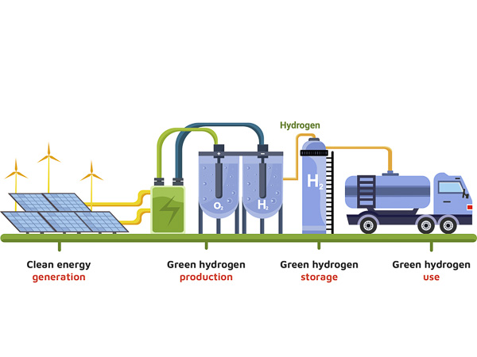
CONCLUSION
Hydrogen energy represents a powerful solution to one of humanity’s greatest challenges meeting the world’s growing energy needs while protecting the environment. As a clean, efficient, and versatile energy carrier, hydrogen has the potential to replace conventional fossil fuels and significantly reduce greenhouse gas emissions. Its only by-product being water makes it an ideal candidate for achieving net-zero carbon goals and promoting global sustainability.
The study reveals that hydrogen can be extracted through various methods such as electrolysis, steam methane reforming, coal gasification, and biomass conversion. Among these, green hydrogen, produced using renewable energy sources, offers the most promising and eco-friendly pathway for large-scale adoption. Hydrogen also provides a vital link between renewable energy generation and energy storage, allowing excess solar and wind power to be stored and used on demand. This makes it a cornerstone for building a flexible and resilient energy system.
The potential applications of hydrogen are vast from transportation (fuel cell vehicles, trains, and aircraft) to industrial sectors such as steelmaking, refining, and fertilizers. Moreover, its use in power generation and grid stabilization further strengthens its position as a key element in the future energy economy. Countries like Japan, Germany, and India are already leading the way through national hydrogen missions, investments, and infrastructure development, demonstrating hydrogen’s real-world viability.
However, realizing a hydrogen-based future requires overcoming several challenges. High production costs, limited infrastructure, and storage difficulties remain significant barriers. To address these, governments, industries, and research institutions must collaborate to accelerate innovation in electrolysis technology, fuel cells, and hydrogen storage systems. Expanding renewable energy capacity and implementing carbon capture solutions will also be crucial for cleaner hydrogen production.
In conclusion, hydrogen stands as the fuel of the future one that can revolutionize the global energy landscape. With continued technological advancements, policy support, and public awareness, hydrogen energy will not only reduce carbon emissions but also create economic opportunities, improve energy security, and ensure environmental sustainability for future generations
TEAM SNAPSHOT
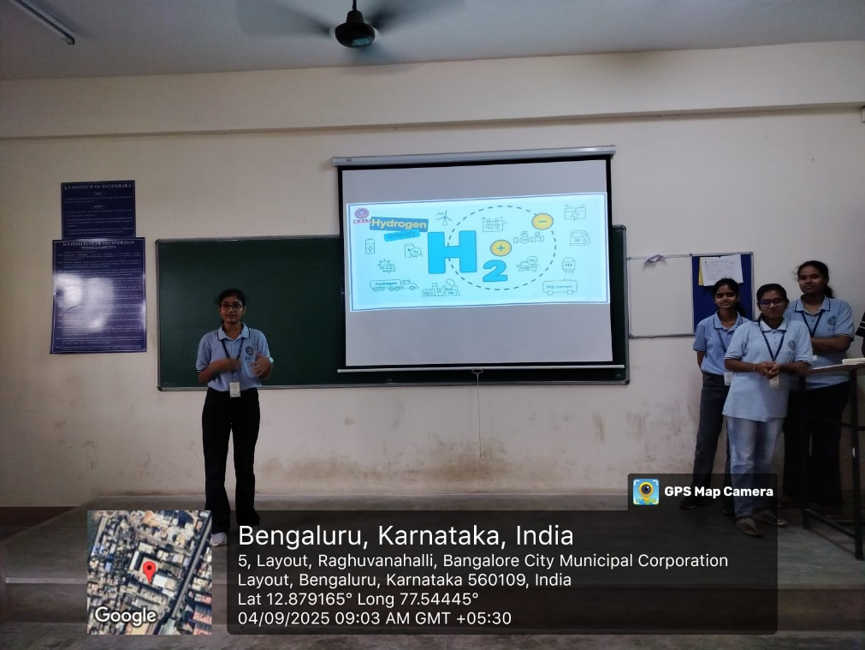

REFERENCES

- https://iea.blob.core.windows.net/assets/8ab96d80-f2a5-4718eb57d3c157599a4/English-Future-Hydrogen-ES.pdf
- https://hydrogencouncil.com/wp-content/uploads/2017/06/Hydrogen-Council-Vision-Document.pdf
- https://digitallibrary.un.org/record/618299/files/Hydrogen_Economy.pdf?ln=ar
- https://energy-transitions.org/wp-content/uploads/2021/04/ETC-Global-Hydrogen-Report.pdf

